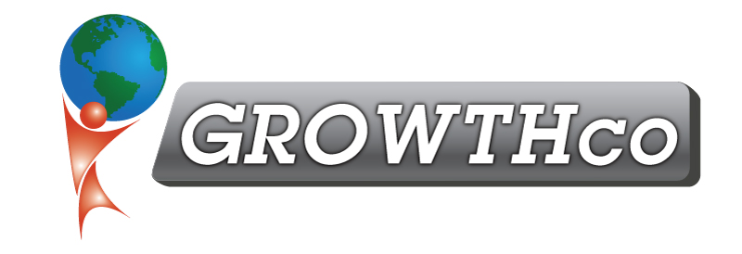
Team Building

Category:
Essential Soft-Skills

Course Prerequisite:
None

Course Length:
12 hours

Materials:
Included (digitally only)

Cancellation Policy:
Less than 14 days, 50% non-refundable , less than 7 days 100% non-refundable
Minimum Number of Students:
4

Maximum Number of Students:
25

Delivery:
vILT or cILT
(virtual or classroom)

Pre-work:
Two Assessment Questionnaires

This classroom-based, adult learning training event promotes team building, morale, and team performance.

Participants learn what teamwork and team building are and the different models for team performance. They will understand the five stages of team performance (Forming, Storming, Norming, Performing, and Adjourning) and create action plans to optimize each one for their own team.

What Participants Will Learn:

- The value of working as a team
- How to develop team processes, ground rules, and team agreements
- Identify each team player’s personality and workstyle and how to adjust your approach to improve communication and effectiveness
- Ways to build team trust
- Three different types of Motivation
- How to create and implement motivational programs and initiatives
- The 4 stages of team building (Form, Storm, Norm, & Perform) and how to help a team move through them
- Ways that team members can be involved and grow in a team setting
- How to develop a High Performing Team
Participants will take a Jung Personality assessment and learn about their personality type and potential strengths and potential weaknesses of that type. Participants will also learn about other personality types and discuss tactics to use when working with people who are different from them.

Participants will also take the TORI Team Building Principles assessment and learn how to optimize Trust, Openness, Realization, and Interdependence in their teams.

