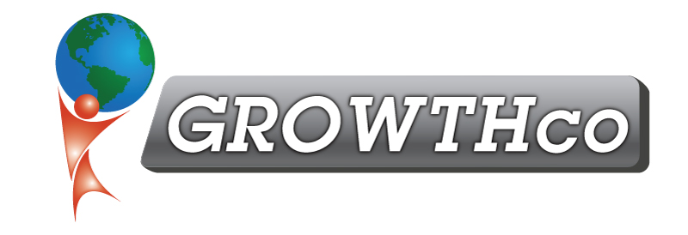
Category:
Sales

Course Prerequisite:
None

Course Length:
16 hours

Materials:
Included (digital only)

Cancellation Policy:
Less than 14 days, 50% non-refundable , less than 7 days 100% non-refundable
Minimum Number of Students:
4

Maximum Number of Students:
15

Delivery:
vILT or cILT
(virtual or classroom)

Pre-work:
None

Outbound Community Sales and Marketing
This course was designed specifically for people who need to go into their local community and create business development and sales opportunities.

Most community sales and business development efforts are done through random activities and a combination of cold calling, networking, chamber memberships, being on Boards of Directors, and developing referral partners and groups. And many more!

Most people have not figured out the strategy to optimize their performance and results.

Outbound Community Sales and Marketing teaches every potential way to increase business and sales. Then, we teach attendees how to create their own strategic sales and marketing plan, leveraging their individual strengths, styles, and personality.

The ‘homework’ will be to develop a strategic plan that will be implemented immediately after the training is complete.

Topics and Objectives include:
    - How to create a community marketing plan
    - How to build relationships in the community
    - How to network
    - How to have a successful tradeshow
    - How to create a targeted prospecting list
    - How to seek and obtain referrals
    - How to optimize your entire sales process from prospecting all the way through post-sales service

